Chapter 12, Solution 19.

For the Δ-Δ circuit of Fig. 12.50, calculate the phase and line currents.

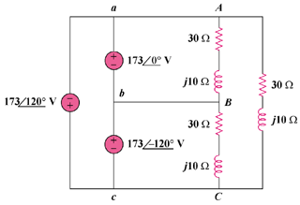

Figure 12.50
For Prob. 12.19.

Solution

The phase currents are

The line currents are

